A Comprehensive Comparison of Process Synchronization Algorithms
Monitor · Semaphore · Peterson · Dekker · Readers–Writers
Details | Value
Title | Comparison of the Monitor, Semaphore, Peterson, Dekker and Readers–Writers Algorithms
Course | Embedded and Real-Time Systems
Author | Zoha Karimifar
Student ID | 1403176015
Supervisor | Majid Shamshirgaran
University | Eshraq Non-Profit University, Bojnord
Date | November 10, 2026
Language | English

Contents
- Abstract
- Introduction and the Critical-Section Problem
- Dekker's Algorithm
- Peterson's Algorithm
- Semaphore
- Monitor
- Readers–Writers Problem
- Comprehensive Comparison Table
- Comparative Charts
- Conclusion
- Glossary and References

1. Abstract
In multiprocess and multithreaded systems, several processes access shared resources concurrently. Without coordination, results depend on scheduling order, producing race conditions. This paper examines five classical synchronization solutions: Dekker's algorithm, Peterson's algorithm, semaphores, monitors, and the readers–writers solutions. For each, we present the core idea, pseudocode, a flowchart, and key properties — mutual exclusion, progress, bounded waiting, busy waiting, starvation and deadlock — followed by a full comparison table and charts.
Keywords: Mutual Exclusion, Critical Section, Semaphore, Monitor, Peterson, Dekker, Readers–Writers, Bounded Waiting, Starvation

2. Introduction and the Critical-Section Problem

2.1. Critical Section
The code segment that touches shared data is the critical section. Every process has an entry section, the critical section, an exit section and a remainder section. A correct solution must satisfy three requirements:
- Mutual Exclusion: at most one process is inside the critical section at any time.
- Progress: if the critical section is free and some processes want to enter, the choice of the next one cannot be postponed indefinitely, and only competing processes take part in the decision.
- Bounded Waiting: after a process requests entry, there is a bound on how many times others may enter before it.

2.2. Race-Condition Example
Suppose two threads execute counter++. At machine level this is three steps (load, add, store). If scheduling interleaves them, one update is lost.
T0: R1 = counter // R1 = 5
T1: R2 = counter // R2 = 5
T0: R1 = R1 + 1 // R1 = 6
T1: R2 = R2 + 1 // R2 = 6
T0: counter = R1 // counter = 6
T1: counter = R2 // counter = 6 (expected 7!)

2.3. Comparison Criteria
Criterion | Description
Mutual exclusion | Guarantees single-process entry
Progress | No indefinite postponement of the decision
Bounded waiting | Upper bound on waiting
Busy waiting | CPU consumed while waiting
Deadlock | Possibility of circular waiting
Starvation | Possibility of indefinite waiting
Scalability | Ability to work with N processes
Hardware support | Need for an atomic instruction
Abstraction level | Software, OS-level or language-level
Ease of use | Likelihood of programmer error

3. Dekker's Algorithm

3.1. Core Idea
Dekker's algorithm (Th. J. Dekker, c. 1965) is the first correct software-only solution to two-process mutual exclusion that needs no special hardware instructions. It uses flag[2] to announce intent and turn to break ties. When both want to enter, the process whose turn it is not temporarily withdraws its flag, waits for its turn, and retries.

3.2. Pseudocode
shared: boolean flag[2] = {false, false};
int turn = 0;
// Process Pi (j = 1 - i)
loop forever:
flag[i] = true; // I want to enter
while flag[j] == true: // other also wants
if turn != i: // not my turn
flag[i] = false; // back off
while turn != i: ; // wait for my turn
flag[i] = true; // try again
// ---- critical section ----
turn = j; // give priority to other
flag[i] = false; // exit
// ---- remainder section ----

3.3. Property Analysis
Mutual exclusion holds because a process enters only when flag[j] is false and its own flag is already true. Progress holds because during contention exactly one process (the holder of turn) proceeds. Bounded waiting holds: on exit turn is handed to the rival, so a waiting process loses at most one turn. Weaknesses: only two processes, busy waiting, conceptual complexity, and a requirement for sequential consistency on modern CPUs (otherwise memory fences are needed).

3.4. Flowchart
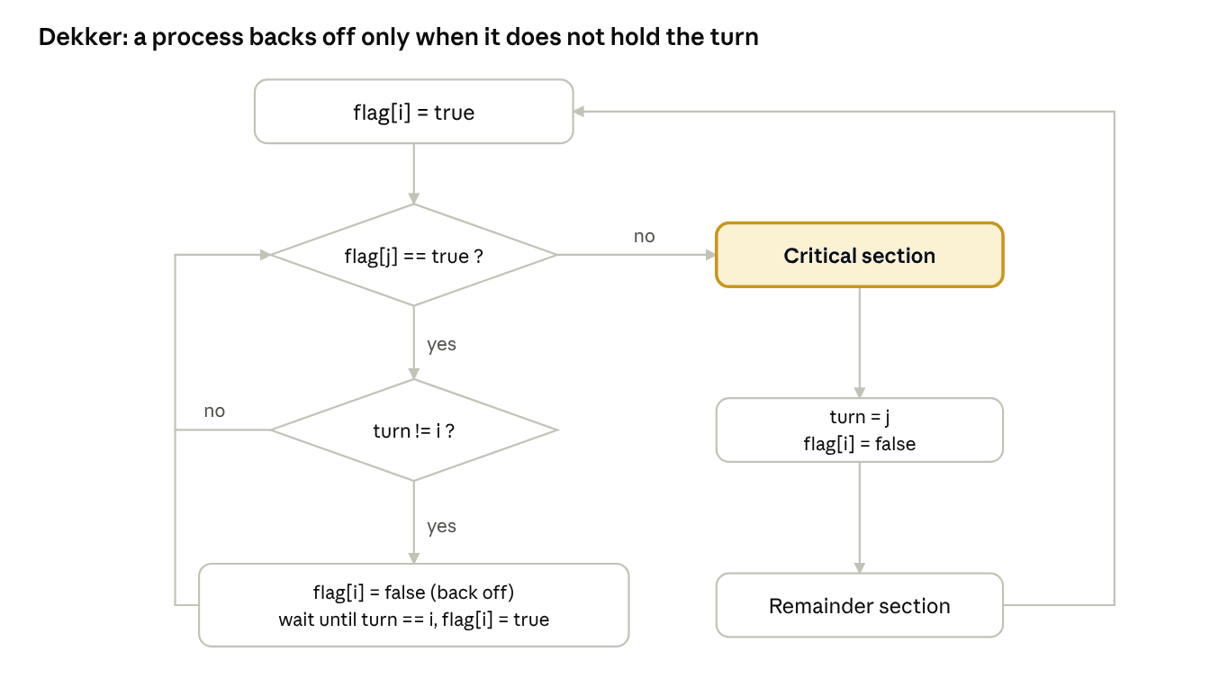
Dekker flowchart · 2 decisions, 1 loop
The loop-back shows that a process without the turn only lowers its flag temporarily, waits, and retries.

3.5. Pros and Cons
Property | Result
Mutual exclusion | ✔ Satisfied
Progress | ✔ Satisfied
Bounded waiting | ✔ at most one turn
Busy waiting | ✘ Yes
Processes | Only 2
Special hardware | None

4. Peterson's Algorithm

4.1. Core Idea
Peterson's algorithm (Gary L. Peterson, 1981) is a much simpler formulation than Dekker's. Each process first raises its flag to announce intent, then gives the turn to its rival (a "polite" gesture). If both do this simultaneously, whoever writes turn last "loses" and waits, because turn then equals the rival's index. Unlike Dekker, no flag withdrawal is needed.

4.2. Two-Process Pseudocode
shared: boolean flag[2] = {false, false};
int turn;
// Process Pi (j = 1 - i)
loop forever:
flag[i] = true; // I want to enter
turn = j; // let the other go first
while (flag[j] == true && turn == j): ; // busy wait
// ---- critical section ----
flag[i] = false; // exit
// ---- remainder section ----

4.3. Proof Sketch
Mutual exclusion: suppose both are in the critical section. Both flags are true, and each passed the loop, so for each one either turn was its own index or the rival's flag was false. Since both flags are true, turn would need to equal both i and j at once — impossible. Bounded waiting: a waiting process sees the rival enter at most once, because on re-entry the rival sets turn in our favour.

4.4. N-Process Generalization (Filter Lock)
The general version uses N−1 "levels", each of which filters out one process. Mutual exclusion and progress hold; starvation is impossible but strict FIFO fairness is not guaranteed (the overtaking bound depends on N).
shared: int level[N] = {-1, ..., -1};
int waiting[N-1];
// Process Pi
for L = 0 to N-2:
level[i] = L;
waiting[L] = i;
while (waiting[L] == i && exists k != i with level[k] >= L): ;
// ---- critical section ----
level[i] = -1;

4.5. Memory-Model Caveat
On modern CPUs, stores may become visible out of order (store buffers). If flag[i] = true is not globally visible before flag[j] is read, mutual exclusion breaks. A safe implementation needs atomic variables with seq_cst ordering or explicit memory fences.

4.6. Flowchart
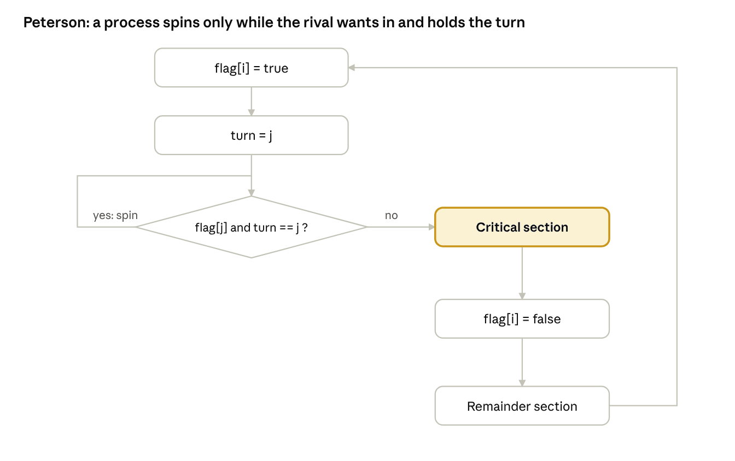
Peterson flowchart · 1 decision, 1 spin loop
The process spins only while the rival is interested and holds the turn.

4.7. Dekker vs. Peterson at a Glance
Property | Dekker | Peterson
Year | ≈1965 | 1981
Shared vars | flag[2] + turn | flag[2] + turn
Code complexity | High | Low
Flag withdrawal | Yes | No
N-process | Hard | Filter lock
Busy waiting | Yes | Yes

5. Semaphore

5.1. Core Idea
The semaphore (Dijkstra, 1965) is a non-negative integer accessible only through two atomic operations: wait (P) and signal (V). wait decrements and blocks the caller if the value goes negative; signal increments and wakes one waiter, if any. The blocking implementation avoids busy waiting. A binary semaphore takes only 0 or 1 and resembles a mutex; a counting semaphore takes any non-negative value and manages pools of identical resources.

5.2. Pseudocode
// (a) Busy-waiting definition
wait(S): while S <= 0: ; // spin
S = S - 1;
signal(S): S = S + 1;
// (b) Blocking definition (no busy waiting)
type semaphore { int value; queue list; }
wait(S):
S.value = S.value - 1;
if S.value < 0:
add this process to S.list;
block(); // sleep
signal(S):
S.value = S.value + 1;
if S.value <= 0:
remove a process P from S.list;
wakeup(P);
// (c) Mutual exclusion with a binary semaphore
semaphore mutex = 1;
loop forever:
wait(mutex);
// ---- critical section ----
signal(mutex);
// ---- remainder section ----

5.3. Producer–Consumer Example
A bounded buffer of capacity N is managed with three semaphores: empty (free slots), full (filled slots) and mutex (exclusive buffer access).
semaphore mutex = 1, empty = N, full = 0;
Producer: Consumer:
loop: loop:
item = produce(); wait(full);
wait(empty); wait(mutex);
wait(mutex); item = buffer.remove();
buffer.insert(item); signal(mutex);
signal(mutex); signal(empty);
signal(full); consume(item);

5.4. Property Analysis
Mutual exclusion and progress hold. Bounded waiting depends on the queue discipline: it holds with a FIFO queue (a strong semaphore) and not with arbitrary wake-up (a weak semaphore). Pitfalls: a wrong wait order (e.g. mutex before empty) deadlocks; a misplaced signal or wait corrupts the system; and priority inversion is possible. Unlike Dekker and Peterson it scales to N processes unchanged, but it needs kernel support and atomic hardware operations (test-and-set or CAS).

5.5. Flowchart
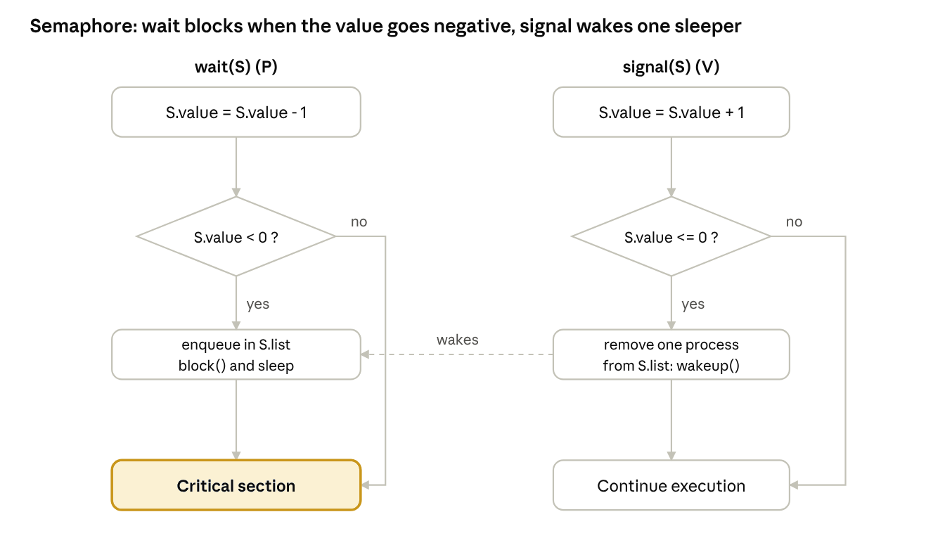
Semaphore flowchart · wait and signal
The chart shows the two atomic operations; the dashed line is the wake-up from signal reaching a sleeping process.

5.6. Pros and Cons
Pros | Cons
Simple, mature, well documented | Error-prone for programmers
No busy waiting | Deadlock with wrong order
Scales to N processes | Priority inversion
Fits both signalling and resources | Locks and signals look the same

6. Monitor

6.1. Core Idea
The monitor (Hoare and Brinch Hansen, 1970s) is a high-level language construct that encapsulates shared data together with the procedures that operate on it. Mutual exclusion is automatic: the compiler acquires the monitor lock on entry and releases it on exit, so the programmer cannot forget a wait or signal. Conditional synchronization (e.g. "buffer full") uses condition variables with wait and signal. Unlike a semaphore, a condition variable has no memory: a signal with no waiter is lost.

6.2. Signal Semantics: Hoare vs. Mesa
Property | Hoare (signal-and-wait) | Mesa (signal-and-continue)
After signal | Signaller yields | Signaller continues
Condition for waiter | Guaranteed true | May have changed
Wait pattern | if | while
Efficiency | More context switches | Fewer
Example | Textbooks | Java, POSIX, C#

6.3. Pseudocode
monitor BoundedBuffer {
item buf[N]; int count = 0, in = 0, out = 0;
condition notFull, notEmpty;
procedure put(item x):
while count == N: wait(notFull); // Mesa style: while, not if
buf[in] = x; in = (in + 1) % N; count++;
signal(notEmpty);
procedure get() returns item:
while count == 0: wait(notEmpty);
x = buf[out]; out = (out + 1) % N; count--;
signal(notFull);
return x;
}
In Java every object has a monitor (synchronized), and wait, notify and notifyAll provide the condition operations with Mesa semantics:
synchronized void put(Object x) throws InterruptedException {
while (count == N) wait();
buf[in] = x; in = (in + 1) % N; count++;
notifyAll();
}

6.4. Property Analysis
Mutual exclusion is guaranteed structurally. Progress holds. Bounded waiting and freedom from starvation depend on the entry-queue and condition-queue policies (Java, for instance, does not specify wake-up order). No busy waiting. Main hazard: the nested monitor problem, which can deadlock. Weakness: needs language or library support and has slightly more overhead than a raw semaphore.

6.5. Flowchart
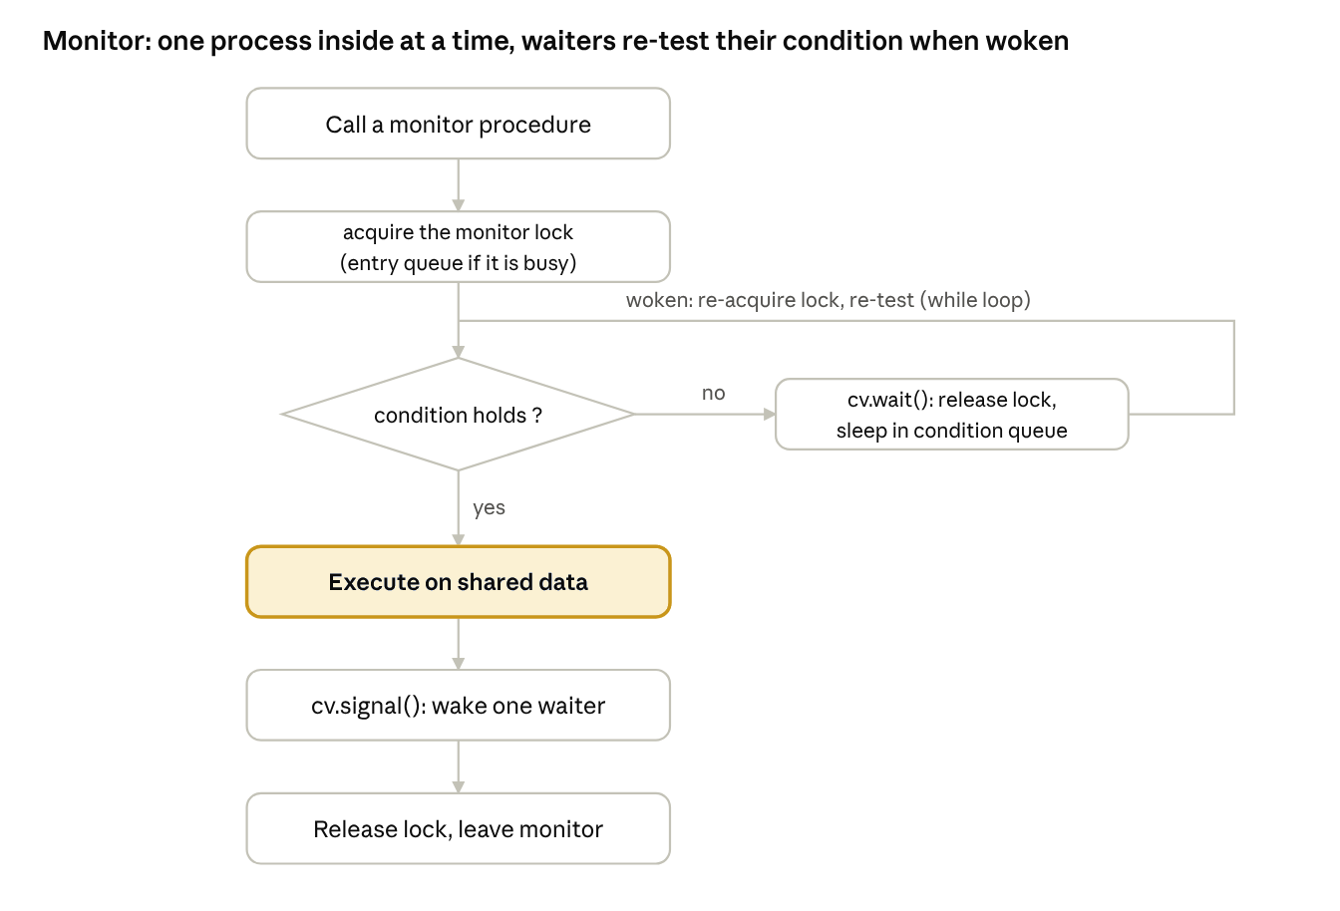
Monitor flowchart · lock, condition, wait/signal
The right-hand loop shows a waiter re-testing its condition after waking (Mesa style).

7. Readers–Writers Problem

7.1. Problem Statement
A set of processes accesses a shared database. Readers only read and may enter concurrently; writers modify and need exclusive access. Rule: any number of concurrent readers, or exactly one writer and no readers. There are three classical variants: reader preference, writer preference, and a fair version.

7.2. Variant 1: Reader Preference
semaphore rw = 1; // exclusive access to the data
semaphore mutex = 1; // protects readcount
int readcount = 0;
Reader: Writer:
wait(mutex); wait(rw);
readcount++; // ---- WRITE ----
if readcount == 1: wait(rw); signal(rw);
signal(mutex);
// ---- READ ----
wait(mutex);
readcount--;
if readcount == 0: signal(rw);
signal(mutex);
The first reader locks writers out and the last reader lets them back in. Problem: if readers keep arriving, a writer never gets its turn (writer starvation).

7.3. Variant 2: Writer Preference
semaphore rmutex = 1, wmutex = 1;
semaphore readTry = 1, resource = 1;
int readcount = 0, writecount = 0;
Reader: Writer:
wait(readTry); wait(wmutex);
wait(rmutex); writecount++;
readcount++; if writecount == 1: wait(readTry);
if readcount == 1: wait(resource); signal(wmutex);
signal(rmutex); wait(resource);
signal(readTry); // ---- WRITE ----
// ---- READ ---- signal(resource);
wait(rmutex); wait(wmutex);
readcount--; writecount--;
if readcount == 0: signal(resource); if writecount == 0: signal(readTry);
signal(rmutex); signal(wmutex);
As soon as a writer arrives, new readers are held back. Problem: reader starvation.

7.4. Variant 3: Fair Version with a Turnstile
semaphore turnstile = 1, roomEmpty = 1, mutex = 1;
int readers = 0;
Writer: Reader:
wait(turnstile); wait(turnstile); // pass through:
wait(roomEmpty); signal(turnstile); // blocked if a writer waits
// ---- WRITE ---- wait(mutex);
signal(turnstile); readers++;
signal(roomEmpty); if readers == 1: wait(roomEmpty);
signal(mutex);
// ---- READ ----
wait(mutex);
readers--;
if readers == 0: signal(roomEmpty);
signal(mutex);
The turnstile prevents endless overtaking by readers: a waiting writer holds the turnstile and new readers stall behind it. With strong (FIFO) semaphores this variant removes both reader and writer starvation.

7.5. Applications and Analysis
The pattern appears in databases, file systems, caches and read–write locks (pthread_rwlock, ReentrantReadWriteLock). Writer exclusion and reader–writer exclusion hold in all variants; the difference lies in bounded waiting and starvation. All three variants can also be implemented with a monitor and condition variables.
Variant | Reader starvation | Writer starvation | Read concurrency
1 – Reader pref. | No | Yes | High
2 – Writer pref. | Yes | No | Lower
3 – Fair | No | No | Medium

7.6. Flowchart (Variant 1)
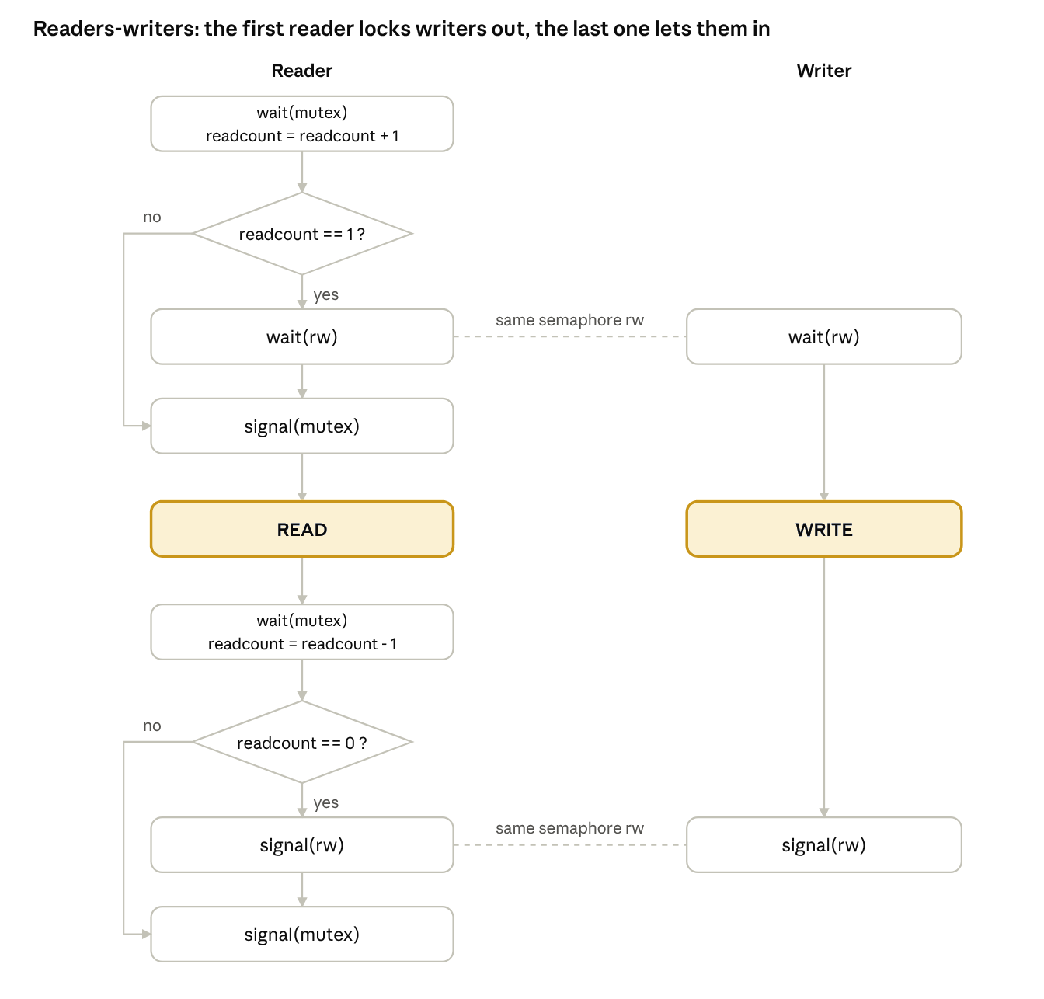
Readers–writers flowchart · first variant
The dashed lines show that readers and writers share one semaphore, rw.

8. Comprehensive Comparison Table
The table compares all five approaches on 17 parameters. The main result: only the higher-level mechanisms (semaphore and monitor) scale to N processes without busy waiting.
Parameter | Dekker | Peterson | Semaphore | Monitor | Readers–Writers
Year and author | ≈1965 T. J. Dekker | 1981 G. L. Peterson | 1965 E. W. Dijkstra | 1974 C. A. R. Hoare | 1971 Courtois, Heymans, Parnas
Type | Software algorithm | Software algorithm | OS primitive | Language construct | Classic problem
Max processes | 2 | 2 (N via filter) | N | N | N
Mutual exclusion | ✔ | ✔ | ✔ | ✔ | ✔ writer exclusive, readers shared
Progress | ✔ | ✔ | ✔ | ✔ | ✔
Bounded waiting | ✔ at most 1 turn | ✔ at most 1 turn | depends on queue (FIFO ✔) | depends on policy | variants 1–2 ✘, 3 ✔
Busy waiting | Yes | Yes | No (blocking) | No | No
Starvation | No | No | Possible (weak) | Possible | V1–2 yes, V3 no
Deadlock | No | No | Possible (wrong order) | Possible (nested) | Possible if misused
Hardware need | Sequential consistency | Memory fences | Atomic ops | Atomics in runtime | As semaphore
Shared variables | flag[2] + turn | flag[2] + turn | int + queue | hidden | 3–6 semaphores and counters
Uncontended entry | few memory ops | few memory ops | one atomic op (+ syscall) | one lock | several atomic ops
Abstraction | Very low | Low | Medium | High | Application pattern
Ease of use | Hard | Medium | Error-prone | Easiest | Hard to get right
Priority inversion | Possible (spin) | Possible (spin) | Possible | Possible | Possible
Typical use | Teaching, theory | Teaching, simple systems | Kernels | Java, C#, POSIX | Databases, rwlocks
Main weakness | Complex, 2 processes | 2 processes, spinning | Deadlocks, human error | Needs language support | Starvation in simple variants
✔ means the property is guaranteed; ✘ means it is not. Priority inversion occurs when a low-priority process holds a lock that a high-priority process is waiting for.

9. Comparative Charts
The charts use the author's qualitative scores (scale 1 to 5, higher is better) on six criteria: scalability, CPU efficiency (no busy waiting), ease and safety of use, fairness (bounded waiting), portability (no special support needed) and deadlock safety. They are not empirical measurements, and the totals are unweighted.

9.1. Scorecard
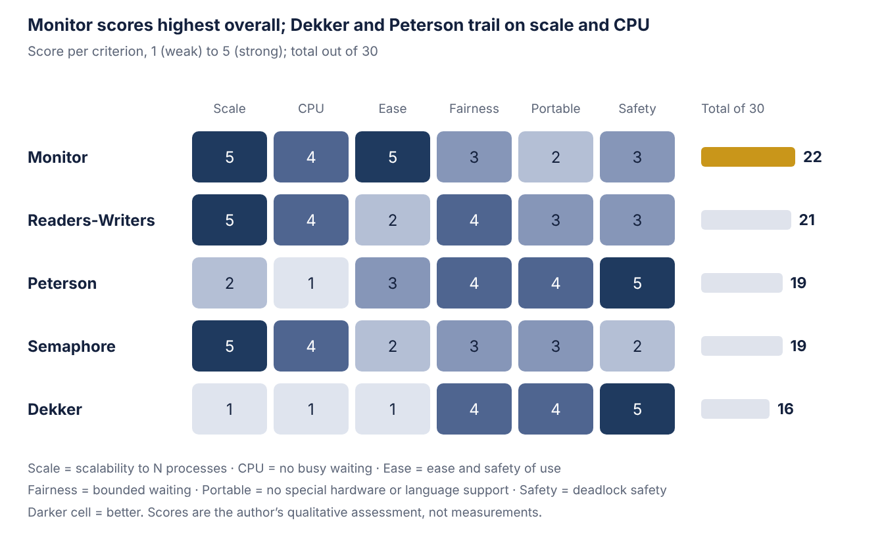
Author's qualitative scoring · 5 methods × 6 criteria
Monitor leads with 22 of 30, followed by Readers–Writers (21), Peterson and Semaphore (19 each) and Dekker (16).

9.2. Profile per Method
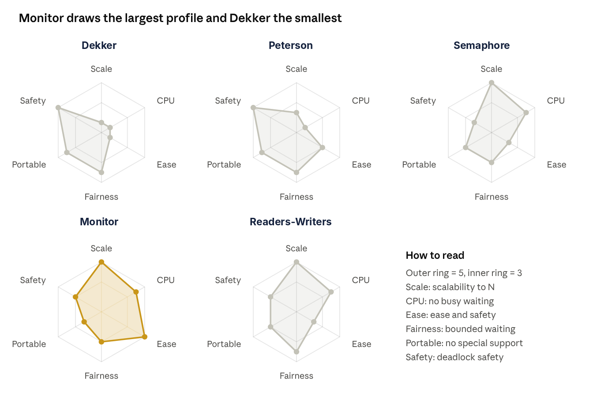
Radar profiles · same scores as the scorecard
The software-only methods (Dekker, Peterson) are strong only on deadlock safety and fairness and weak on scalability and CPU use; the high-level mechanisms show the opposite pattern.

10. Conclusion
No method wins on every criterion; the choice depends on the execution environment. Dekker and Peterson need no special support and are valuable for understanding mutual exclusion, but they cover only two processes and waste CPU on busy waiting. The semaphore is the general-purpose OS tool for both mutual exclusion and event signalling, yet leaves the burden of correctness on the programmer. The monitor hides the lock inside a language construct, making it the safest and most readable option in Java, C# and POSIX. The readers–writers problem shows that even with the right tool, the scheduling policy (reader, writer or fair preference) determines starvation and throughput.

10.1. Selection Guide
Situation | Recommendation
Teaching and correctness proofs | Dekker or Peterson
Kernel or low-level code | Semaphore or atomic spinlock
Application code in Java, C#, Python | Monitor
Read-heavy shared data | Fair readers–writers lock
Real-time system | Semaphore or monitor with priority inheritance

11. Glossary
Term | Short definition
Critical section | Code that touches shared data
Mutual exclusion | At most one process inside
Race condition | Result depends on scheduling order
Progress | No indefinite postponement of the entry decision
Bounded waiting | Upper bound on overtaking
Busy waiting | Spinning and burning CPU
Starvation | A process waits forever
Deadlock | Circular wait among processes
Atomic operation | Operation that cannot be interrupted midway
Condition variable | Wait queue for a condition in a monitor
Priority inversion | Low-priority process blocks a high-priority one
Memory fence | Instruction that orders memory accesses

12. References
- Dijkstra, E. W. (1965). Solution of a problem in concurrent programming control. Communications of the ACM, 8(9), 569.
- Dijkstra, E. W. (1968). Cooperating sequential processes (EWD123). Technological University Eindhoven.
- Courtois, P. J., Heymans, F., & Parnas, D. L. (1971). Concurrent control with “readers” and “writers”. Communications of the ACM, 14(10), 667–668.
- Brinch Hansen, P. (1973). Operating System Principles. Prentice Hall.
- Hoare, C. A. R. (1974). Monitors: An operating system structuring concept. Communications of the ACM, 17(10), 549–557.
- Lampson, B. W., & Redell, D. D. (1980). Experience with processes and monitors in Mesa. Communications of the ACM, 23(2), 105–117.
- Peterson, G. L. (1981). Myths about the mutual exclusion problem. Information Processing Letters, 12(3), 115–116.
- Herlihy, M., & Shavit, N. (2012). The Art of Multiprocessor Programming (Rev. 1st ed.). Morgan Kaufmann.
- Tanenbaum, A. S., & Bos, H. (2014). Modern Operating Systems (4th ed.). Pearson.
- Silberschatz, A., Galvin, P. B., & Gagne, G. (2018). Operating System Concepts (10th ed.). Wiley.
- Downey, A. B. (2016). The Little Book of Semaphores (2nd ed.). Green Tea Press.

